***Pickup a package* Use Case Description**

|  |  |  |
| --- | --- | --- |
| **Use case name:** | *Pickup a parcel.* | |
| **Scenario:** | Picks up parcels. | |
| **Triggering event:** | Driver arrives to pick up parcels. | |
| **Brief description:** | When the driver arrives to pick up the parcels, they can review, edit, and add information and print receipts and labels. | |
| **Actors:** | Driver, customer. | |
| **Related use cases:** | *Request a package pickup* | |
| **Stakeholders:** | Commissioner, drivers, customers. | |
| **Preconditions:** | Customer must have ordered delivery.  Driver must be picking up parcel. | |
| **Postconditions:** | Driver will be able to review information.  Driver will be able to edit information.  Driver will be able to add information.  Driver will be able to print receipts.  Driver will be able to print labels. | |
| **Flow of activities:** | **Actor** | **System** |
| 1. Driver arrives at pickup location. 2. Driver receives parcel(s). 3. Driver collects money, if cash payment. 4. Driver prints mailing label or receipt. | 1.1 System displays available package information.  2.1 Driver makes edits in system parcel information if necessary.  3.1 Driver enters cash payment into system.  4.1 Driver uses system information to print mailing labels or receipts. |
| **Exception conditions:** |  | |

**Use Case Activity Diagram**

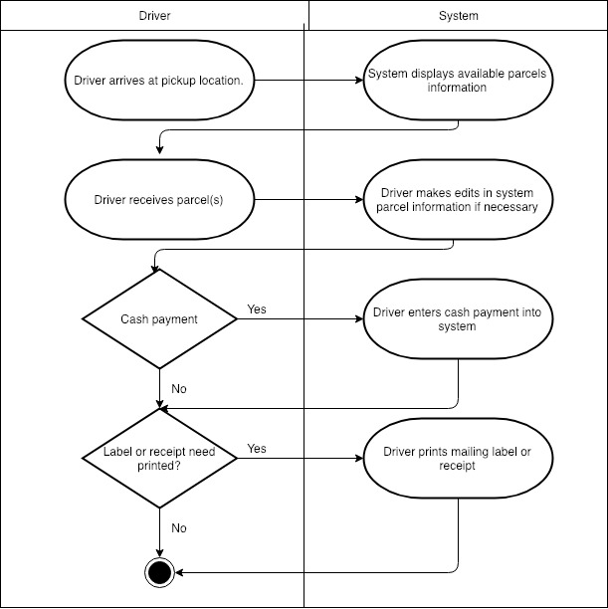

**System Sequence Diagram**

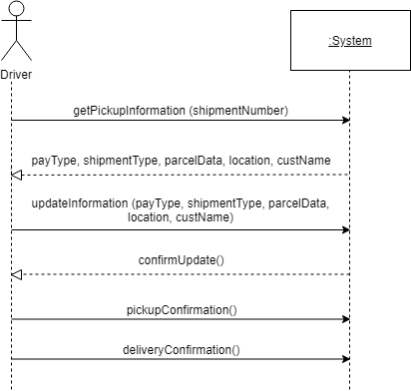



Milestone 5